FBB1

Header information:

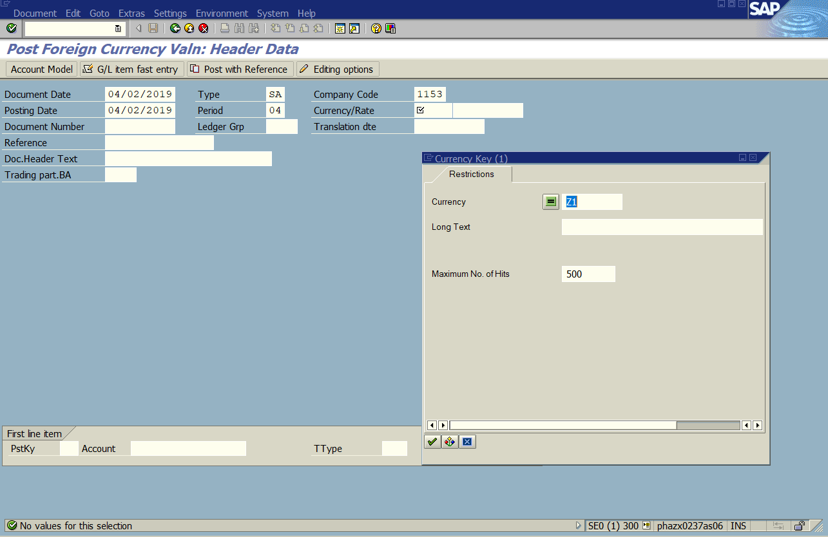

No Z1 (4th currency) as an option. Selected EUR for this but we do not want Local currency, Doc Currency or Group Currency populated.

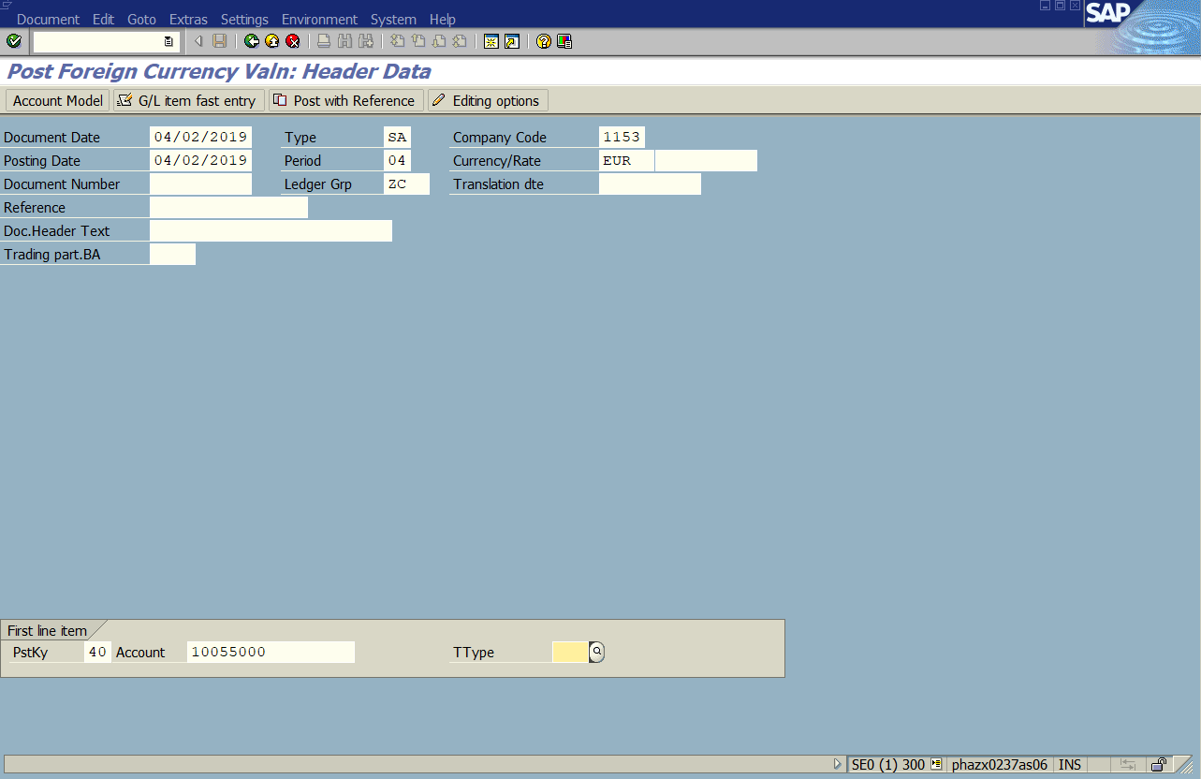

There is no option for debit/credit currency as there is on the fiori tile.

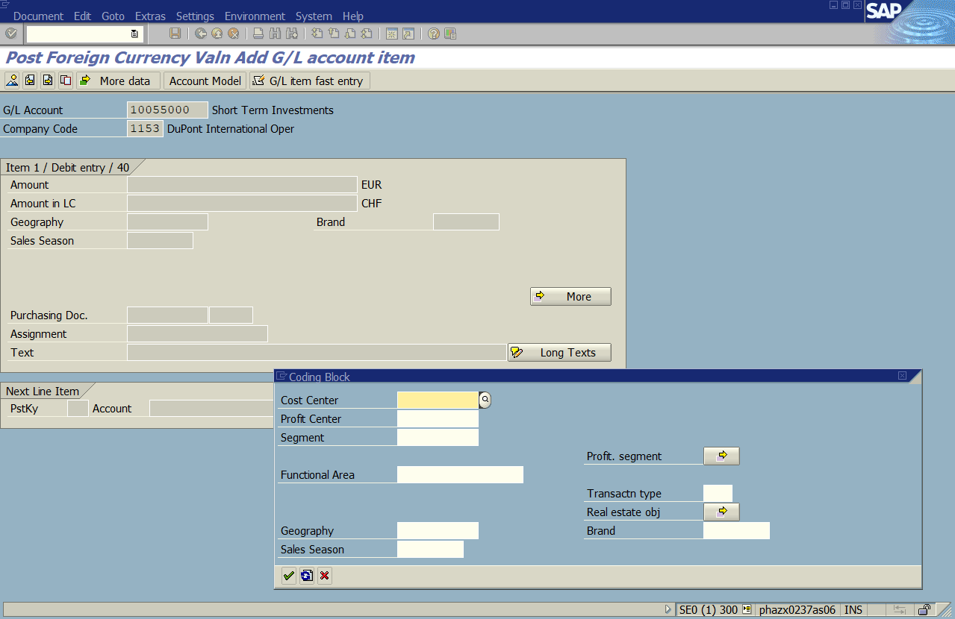



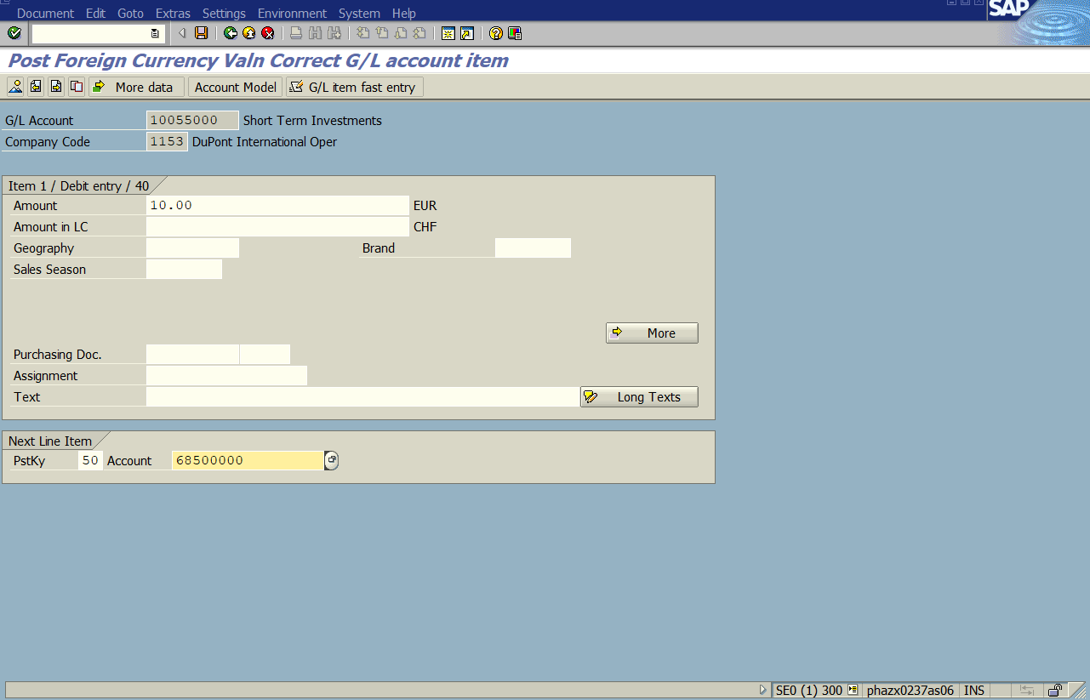

Enter in an amount, then the next line item information posting key and account, and hit enter

Enter in the amount and the cost center, DE58QP1000 then hit enter, afterwards hit Shift+F2

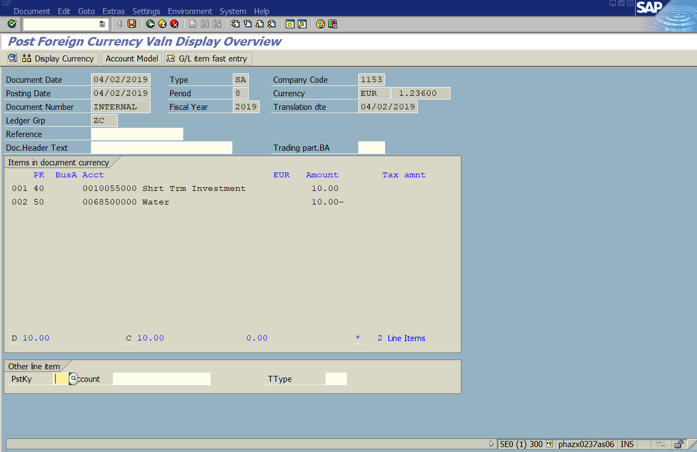

Then hit save to post the document.

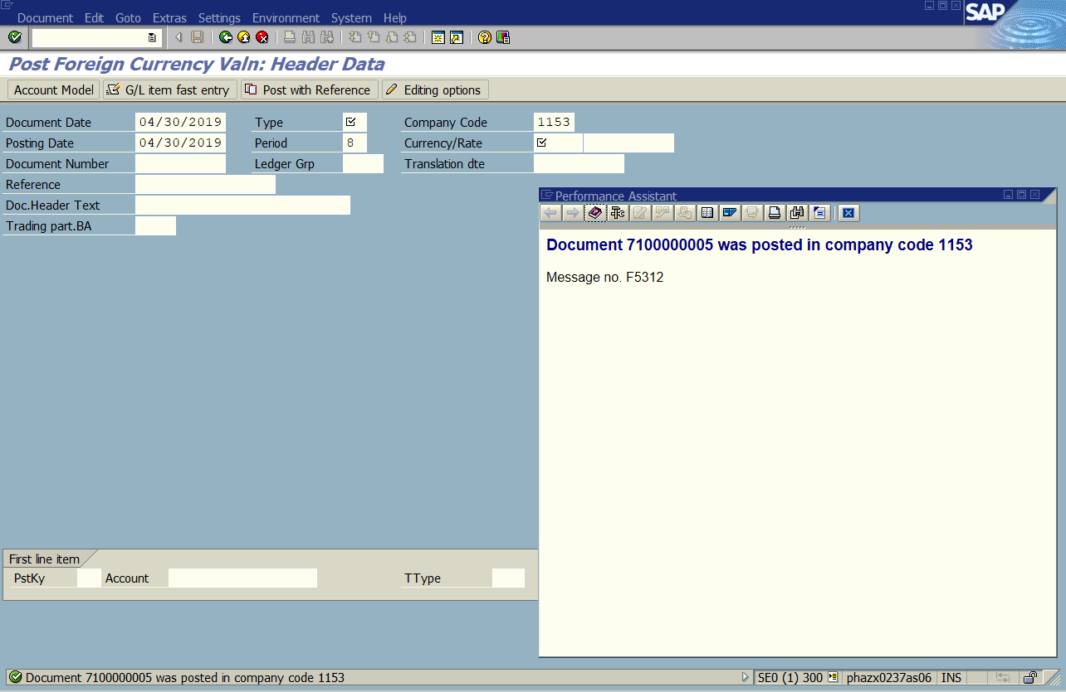

FBB1 Document:

Company Code: 1153 Document: 7100000005 Fiscal Year: 2019

Compare to Fiori Document:

Company Code: 1153 Document: 7100000004 Fiscal Year: 2019

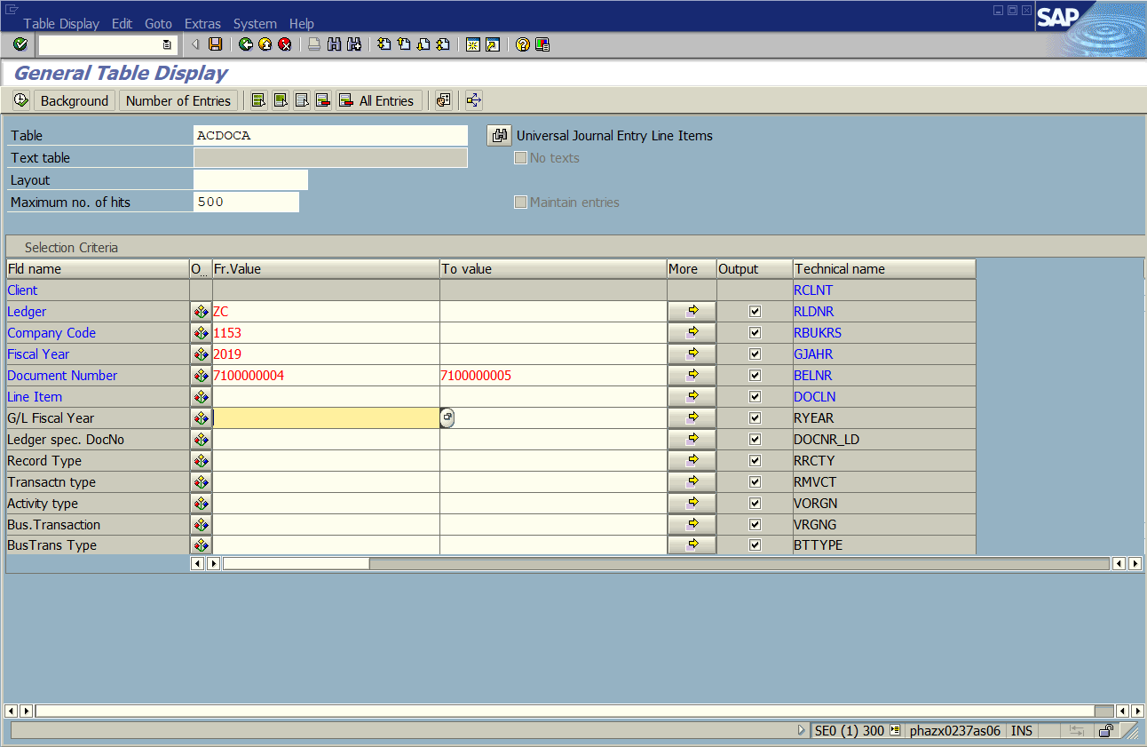

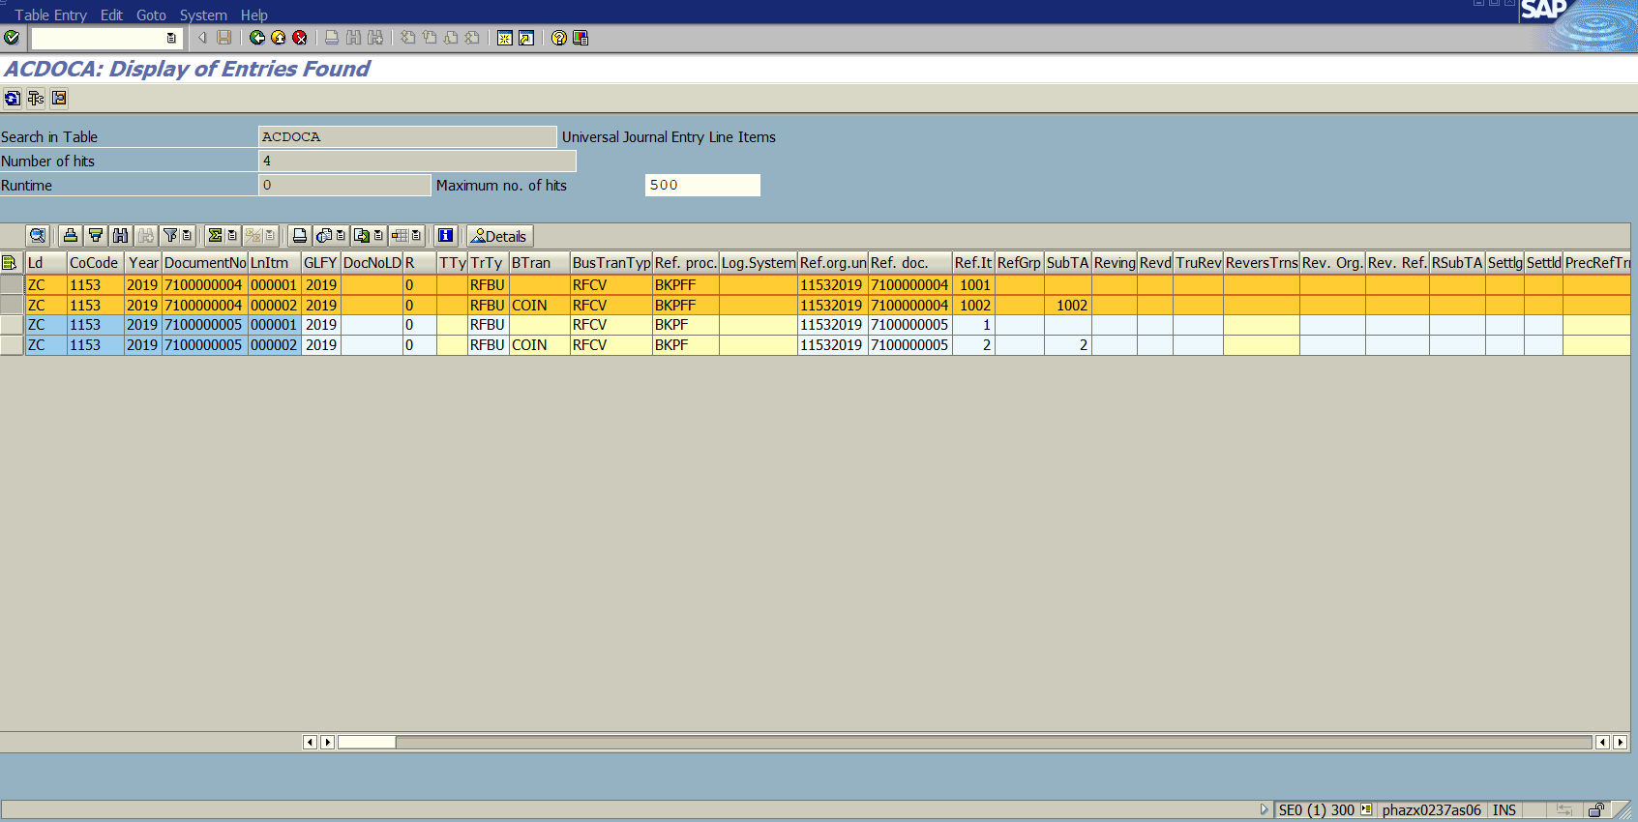

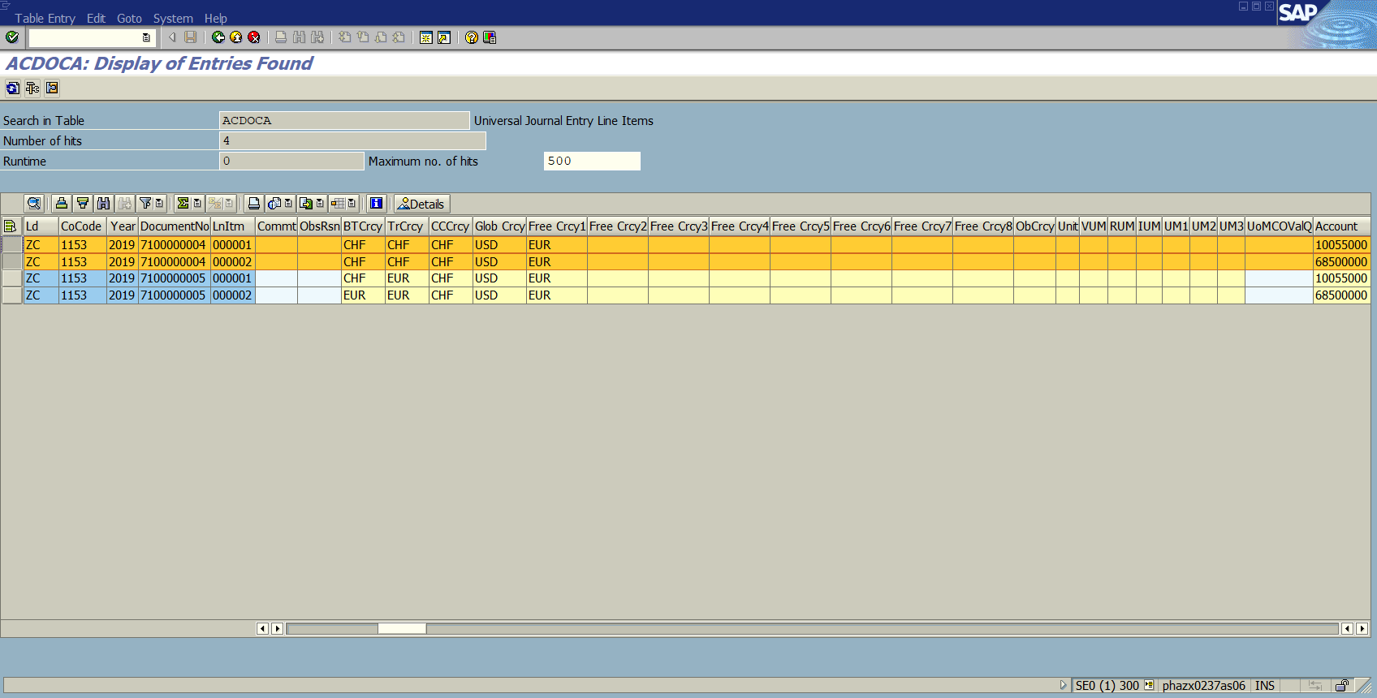

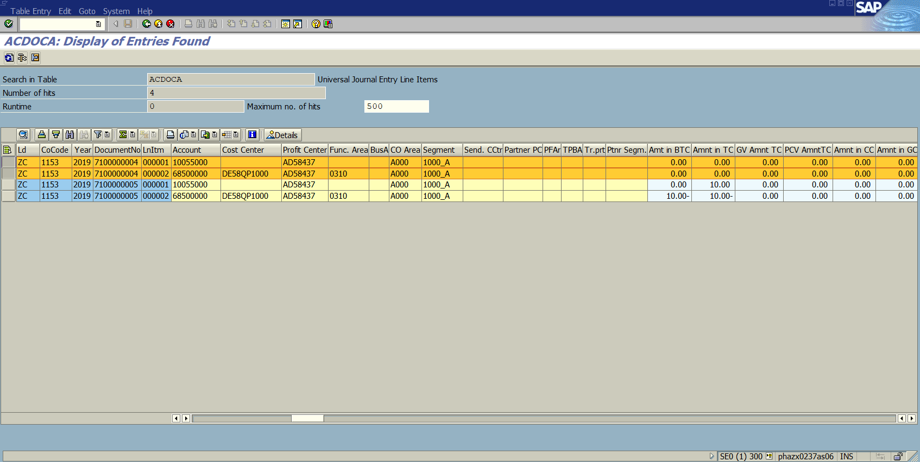

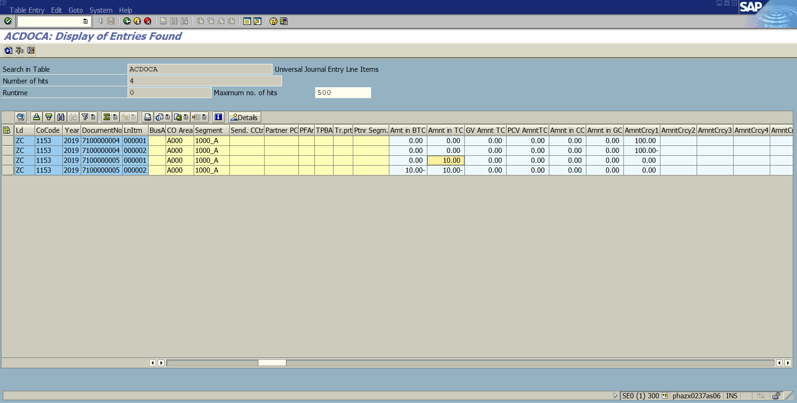



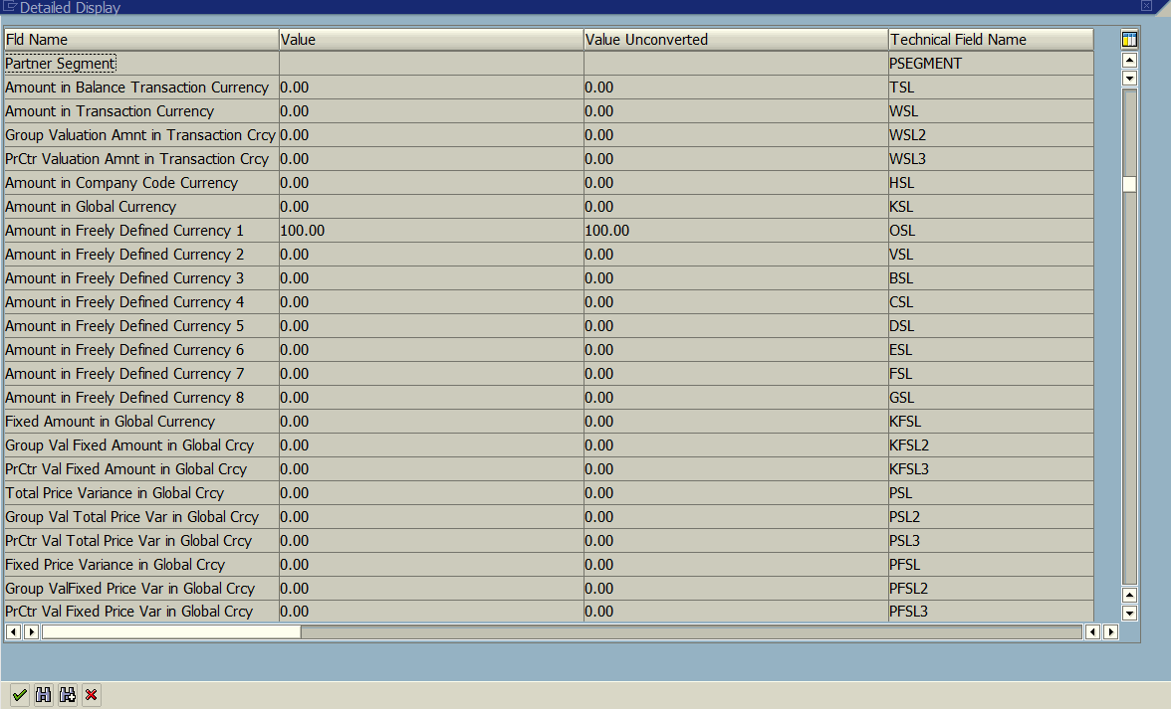

Details for fiori line item above, details for FBB1 Line Item below



